Test Plan and Results
Echo-Innovatech Solutions — 2-Tier Cloud Environment
Version: 1.0 · Date: 30/09/2026· Author: Jonathan Shannon

Contents
1. Introduction 4
2. Test Environment Configuration 5
3. Functional & Integration Test Results 6
T-01: Public Application Access via ALB 6
T-02: REST API Endpoint Verification 6
T-03: Direct Internet Reachability Block on Database Tier 7
T-04: Authorized Management Path to Database Tier 7
T-05: Application Persistence & Real-Time Write Propagation 8
T-06: VPN-Gated Management Network Control 9
4. Monitoring & Alerting Test Results 10
T-07: Automatic Compute Target Discovery 10
T-08: Per-Instance Metric Attribution 10
T-09: Automated Alerting Pipeline Verification 11
T-10: Monitoring Metric Justification & Scaling Alignment 12
5. Scaling, Resilience, and Self-Healing Results 13
T-11: Sustained Load Generation & Bottleneck Analysis 13
T-12: Target-Tracking Auto Scaling Trigger 13
T-13: Scale-In & Cost Optimization Behaviour 14
T-14: EC2 Instance Self-Healing Verification 15
T-15: Zero-Downtime Rolling Deployment 16
6. Security & Compliance Test Results 17
T-16: Keyless Pipeline Authentication via OIDC 17
T-17: Enforcement of Least-Privilege IAM Boundaries 17
T-18: Multi-Tier Network Segmentation Verification 18
7. Failure Scenarios and Recovery Operational Analysis 19
Web Instance Hardware / OS Crash 19
Application Container Crash 19
Sudden Traffic Saturation Bottleneck 19
Pipeline Infrastructure Teardown Failure (Dependency Violation) 19
Pipeline State Discrepancies 20
8. Conclusion 21

1. Introduction
This document describes the testing performed against the deployed Echo-Innovatech environment and presents the resulting evidence. The core objective was to verify that the deployed infrastructure behaves in strict accordance with the specifications established in the Requirement Analysis, and to demonstrate that resilience mechanisms—such as autoscaling, self-healing, central monitoring, and pipeline-driven deployment—function as designed under operational load rather than merely existing as static Terraform configurations.
Testing was conducted against a live environment built entirely by the automated CI/CD pipeline. Evidence gathered during execution is integrated directly into each evaluation section below via verification logs and visual screenshots.

2. Test Environment Configuration
- Cloud Platform: AWS (eu-central-1), provisioned entirely via Infrastructure as Code (Terraform).
- Web & Compute Tier: 2–4 $×$ t3.micro EC2 instances managed by an Auto Scaling Group (ASG), running containerized workloads (Nginx reverse proxy $→$ Gunicorn WSGI $→$ Flask Application) via Docker.
- Database Tier: Amazon RDS PostgreSQL 17 deployed in a Multi-AZ, isolated private subnet configuration.
- Monitoring & Observability: Prometheus server, Grafana dashboards, and Node Exporter agents, integrated with Discord webhook alerts.
- Deployment Pipeline: GitHub Actions executing on a self-hosted runner (vSphere VM) utilizing OpenID Connect (OIDC) federation for keyless AWS authentication.
- Testing Tooling: curl, hey (HTTP load generator), psql (executed from containerized VPN management host), AWS CLI, and native browser access over OpenVPN.

3. Functional & Integration Test Results

T-01: Public Application Access via ALB
- Objective: Confirm that the public Application Load Balancer (ALB) correctly receives incoming web requests on port 80 and routes them to healthy backend web instances, serving database-backed HTML content.
- Execution Method: Executed a standard HTTP GET request using curl http://<ALB-DNS-NAME>/ from an external client.
- Expected Result: The HTTP server renders an HTML document displaying the seeded team members fetched dynamically from PostgreSQL.
- Actual Result: The ALB responded with HTTP status 200 OK and returned the HTML page containing the header "Team (live from RDS Postgres)" along with seeded rows for Alice, Bob, and Carol.
- Verdict: PASS
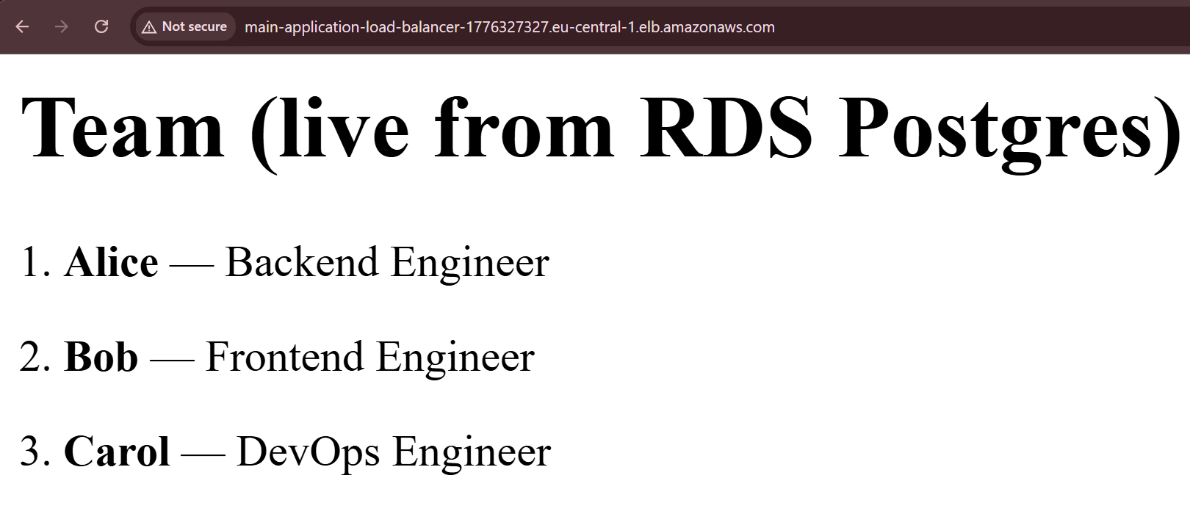

T-02: REST API Endpoint Verification
- Objective: Verify that the backend Flask application successfully handles JSON API queries backed by live database reads.
- Execution Method: Issued an HTTP request targeting curl http://<ALB-DNS-NAME>/api/members.
- Expected Result: A valid JSON array returning the current team member objects from the database.
- Actual Result: Returned a formatted JSON array containing objects matching the PostgreSQL database records (id, name, role).
- Verdict: PASS
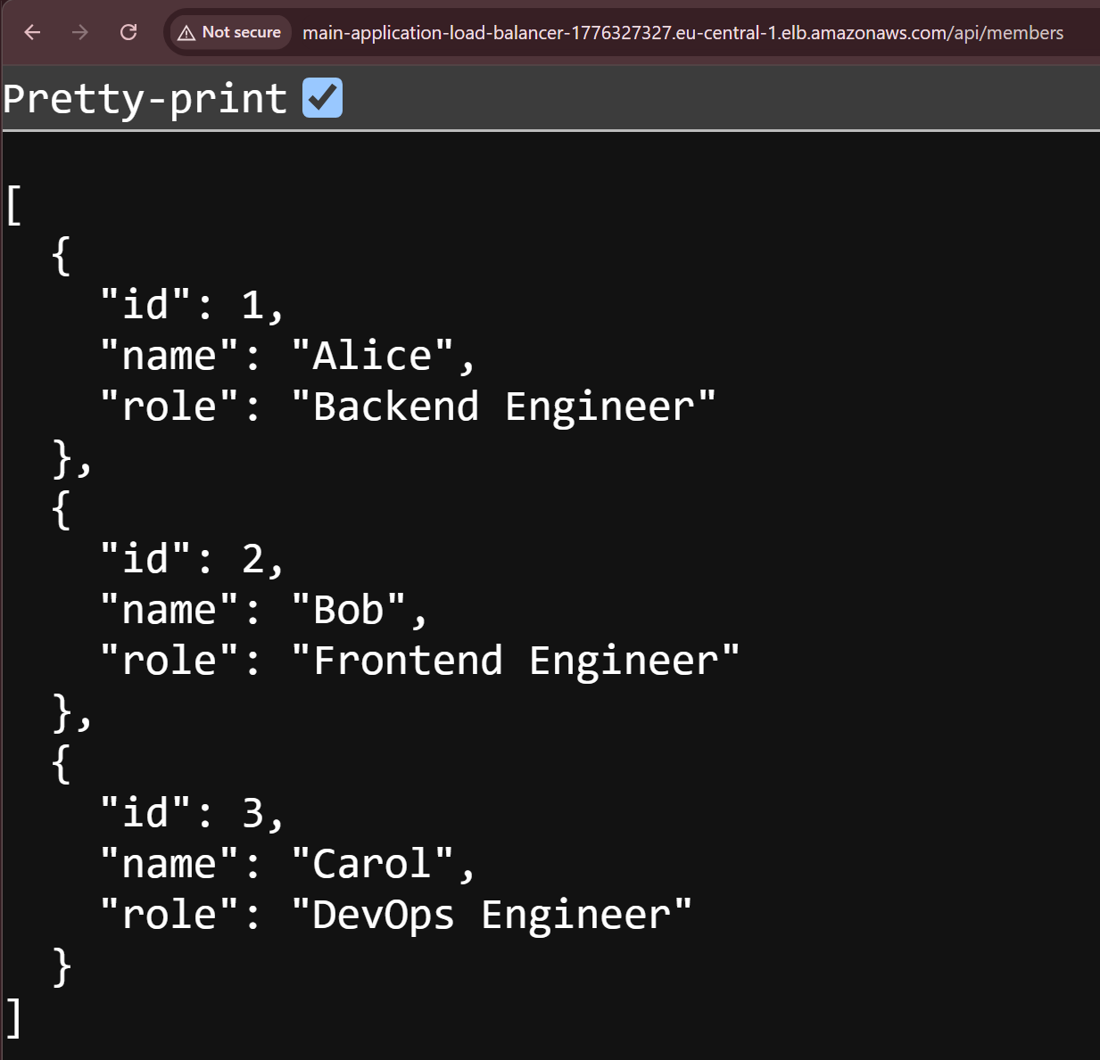

T-03: Direct Internet Reachability Block on Database Tier
- Objective: Ensure the Amazon RDS instance is fully isolated in private subnets and completely unreachable from the public internet.
- Execution Method: Attempted a direct TCP connection to the PostgreSQL database endpoint on port 5432 from a laptop outside the corporate VPN environment using psql and nc.
- Expected Result: Connection attempt times out or is actively refused or claims not to exist, proving no direct public route or security group ingress exists.
- Actual Result: Connection timed out. Routing table entries and security group restrictions effectively drop all incoming public traffic.
- Verdict: PASS

T-04: Authorized Management Path to Database Tier
- Objective: Verify that database management access is strictly permitted through the authorized bastion/VPN host management path.
- Execution Method: Established an SSH tunnel to the OpenVPN gateway host, launched a containerized psql client permitted by db_sg, and executed SELECT * FROM team_members;.
- Expected Result: Successful login, authentication, and execution of SQL queries against the private RDS instance.
- Actual Result: Connection was accepted. The query returned all three active records (Alice, Bob, Carol).
- Verdict: PASS
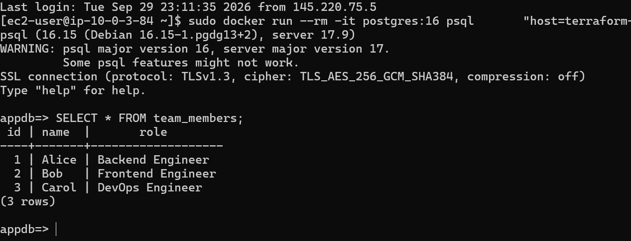

T-05: Application Persistence & Real-Time Write Propagation
- Objective: Confirm that write operations performed on the PostgreSQL database immediately update the public web interface rendered through the ALB without requiring service restarts or redeployments.
- Execution Method: Inserted a new record directly into PostgreSQL (INSERT INTO team_members (name, role) VALUES ('Dave', 'SRE');) via the VPN management connection, then re-fetched the public ALB endpoint.
- Expected Result: The newly inserted entry immediately appears on the web frontend page.
- Actual Result: Upon refreshing the HTTP page, "Dave — SRE" appeared in the team listing.
- Verdict: PASS
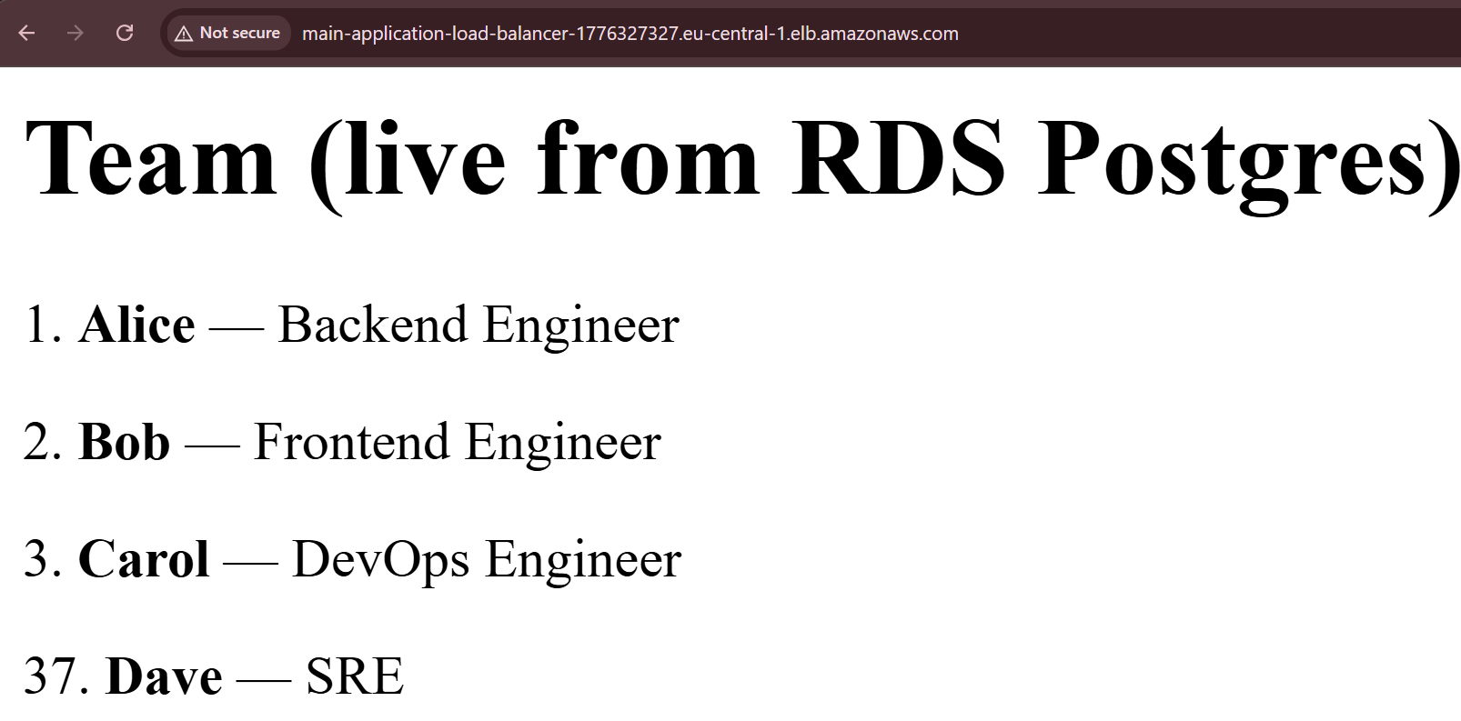
- Personal Notes / Observations: Here is the code running the Insert command and Select to be displayed in the webserver as shown above.
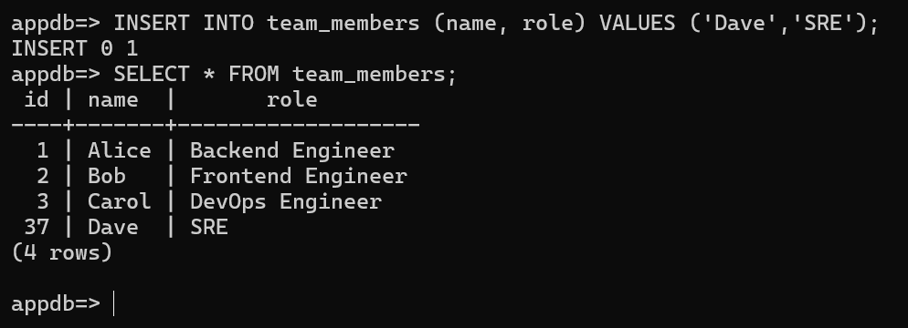

T-06: VPN-Gated Management Network Control
- Objective: Validate that sensitive operational interfaces (Grafana, Prometheus, SSH) are completely inaccessible over the public internet and require active OpenVPN tunnel connection.
- Execution Method: Attempted web browser requests to the Grafana URL (port 3000) and SSH connections (port 22) with the VPN client disconnected, and then repeated the attempt with the OpenVPN client active.
- Expected Result: Requests fail completely while off VPN; requests succeed immediately once connected to the VPN.
- Actual Result: Browsing failed (connection timeout) without the VPN. Once authenticated through OpenVPN, access to ports 3000, 9090, and 22 operated seamlessly.
- Verdict: PASS
Screenshot of a failed attempt without a VPN connection
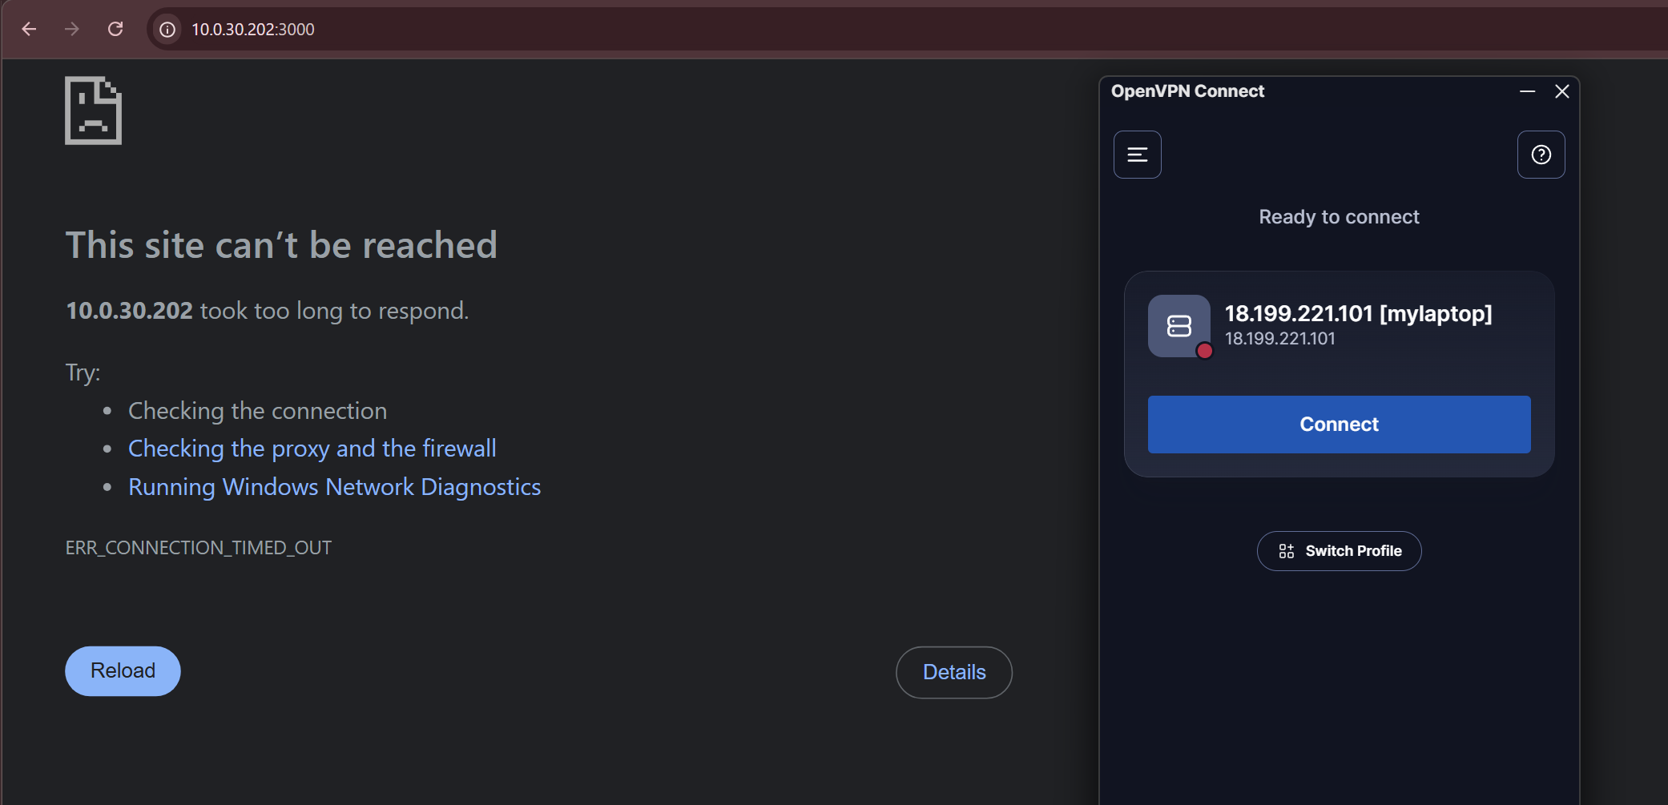
Screenshot of a successful attempt with a VPN connection
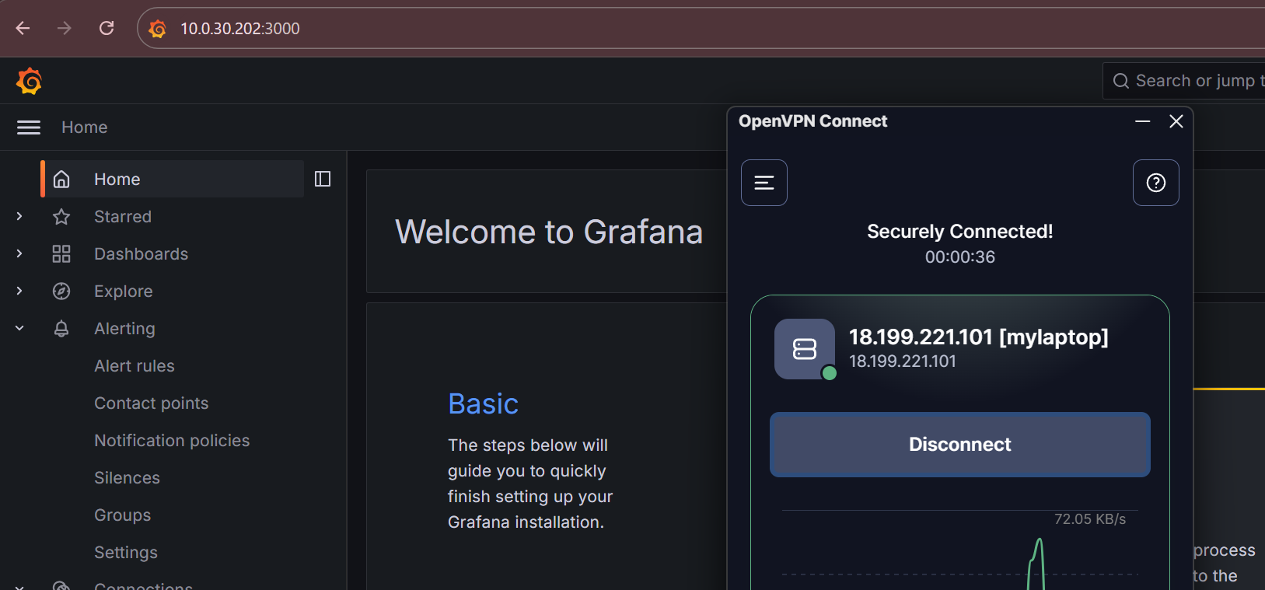

4. Monitoring & Alerting Test Results

T-07: Automatic Compute Target Discovery
- Objective: Confirm that all running EC2 compute instances are dynamically discovered by Prometheus without requiring hardcoded configuration updates.
- Execution Method: Queried Prometheus targets and inspected the Grafana up metric after initial cluster provisioning.
- Expected Result: All active web nodes register as UP via EC2 service discovery integration.
- Actual Result: Prometheus automatically discovered both running web instances via AWS tags. Both targets registered in an UP state.
- Verdict: PASS

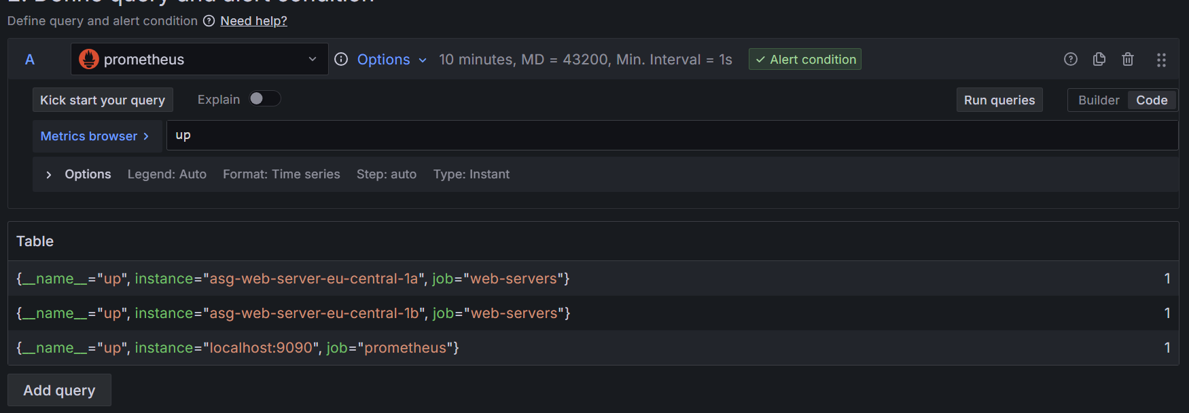
- Description: Screenshot showing the Grafana target dashboard showing the two webservers right after connecting the stock Grafana with the pre-configured Prometheus alone and showing the results of the query immediately afterwards.

T-08: Per-Instance Metric Attribution
- Objective: Ensure performance metrics are clearly separated and accurately attributed by instance ID and Availability Zone on monitoring dashboards.
- Execution Method: Inspected CPU and memory usage panels on the central Grafana dashboard during normal operational load, verifying metric labels using {{instance}}.
- Expected Result: Individual time-series graphs mapped distinct performance curves for each EC2 instance.
- Actual Result: Metrics were parsed individually by instance ID and AZ tag (eu-central-1a vs. eu-central-1b), enabling granular node monitoring.
- Verdict: PASS
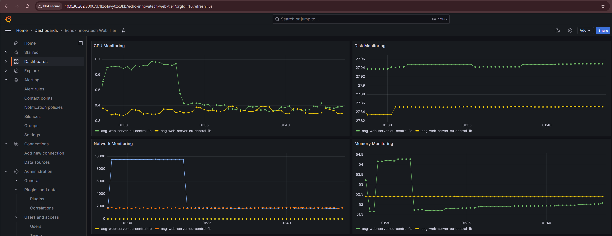
- Description: Screenshot of the main Grafana panel illustrating separate lines for web-server-1 and web-server-2 CPU/Memory usage.

T-09: Automated Alerting Pipeline Verification
- Objective: Verify that failure conditions (such as instance downtime or high resource utilization) trigger automated alert rules in Grafana and deliver notifications to Discord.
- Execution Method: Evaluated configured alert rules (up == 0 for 2 min, CPU $>85\%$, Memory $>85\%$) and simulated an alert state by terminating a target node or spiking resource usage.
- Expected Result: Grafana shifts rule state to Firing and dispatches a JSON payload via webhook to the designated Discord channel.
- Actual Result: Alert triggered as expected. A notification detailing the affected instance and firing rule was received in Discord.
- Verdict: PASS
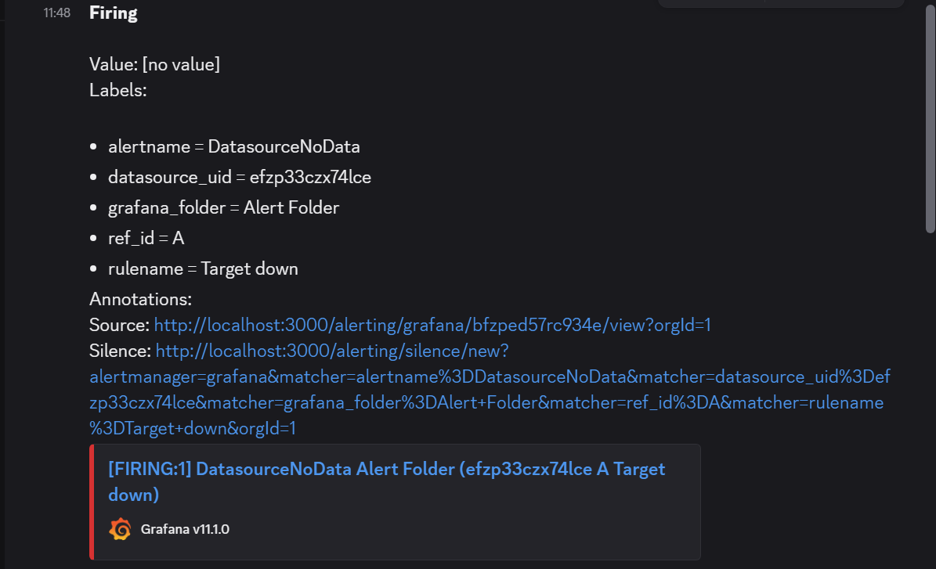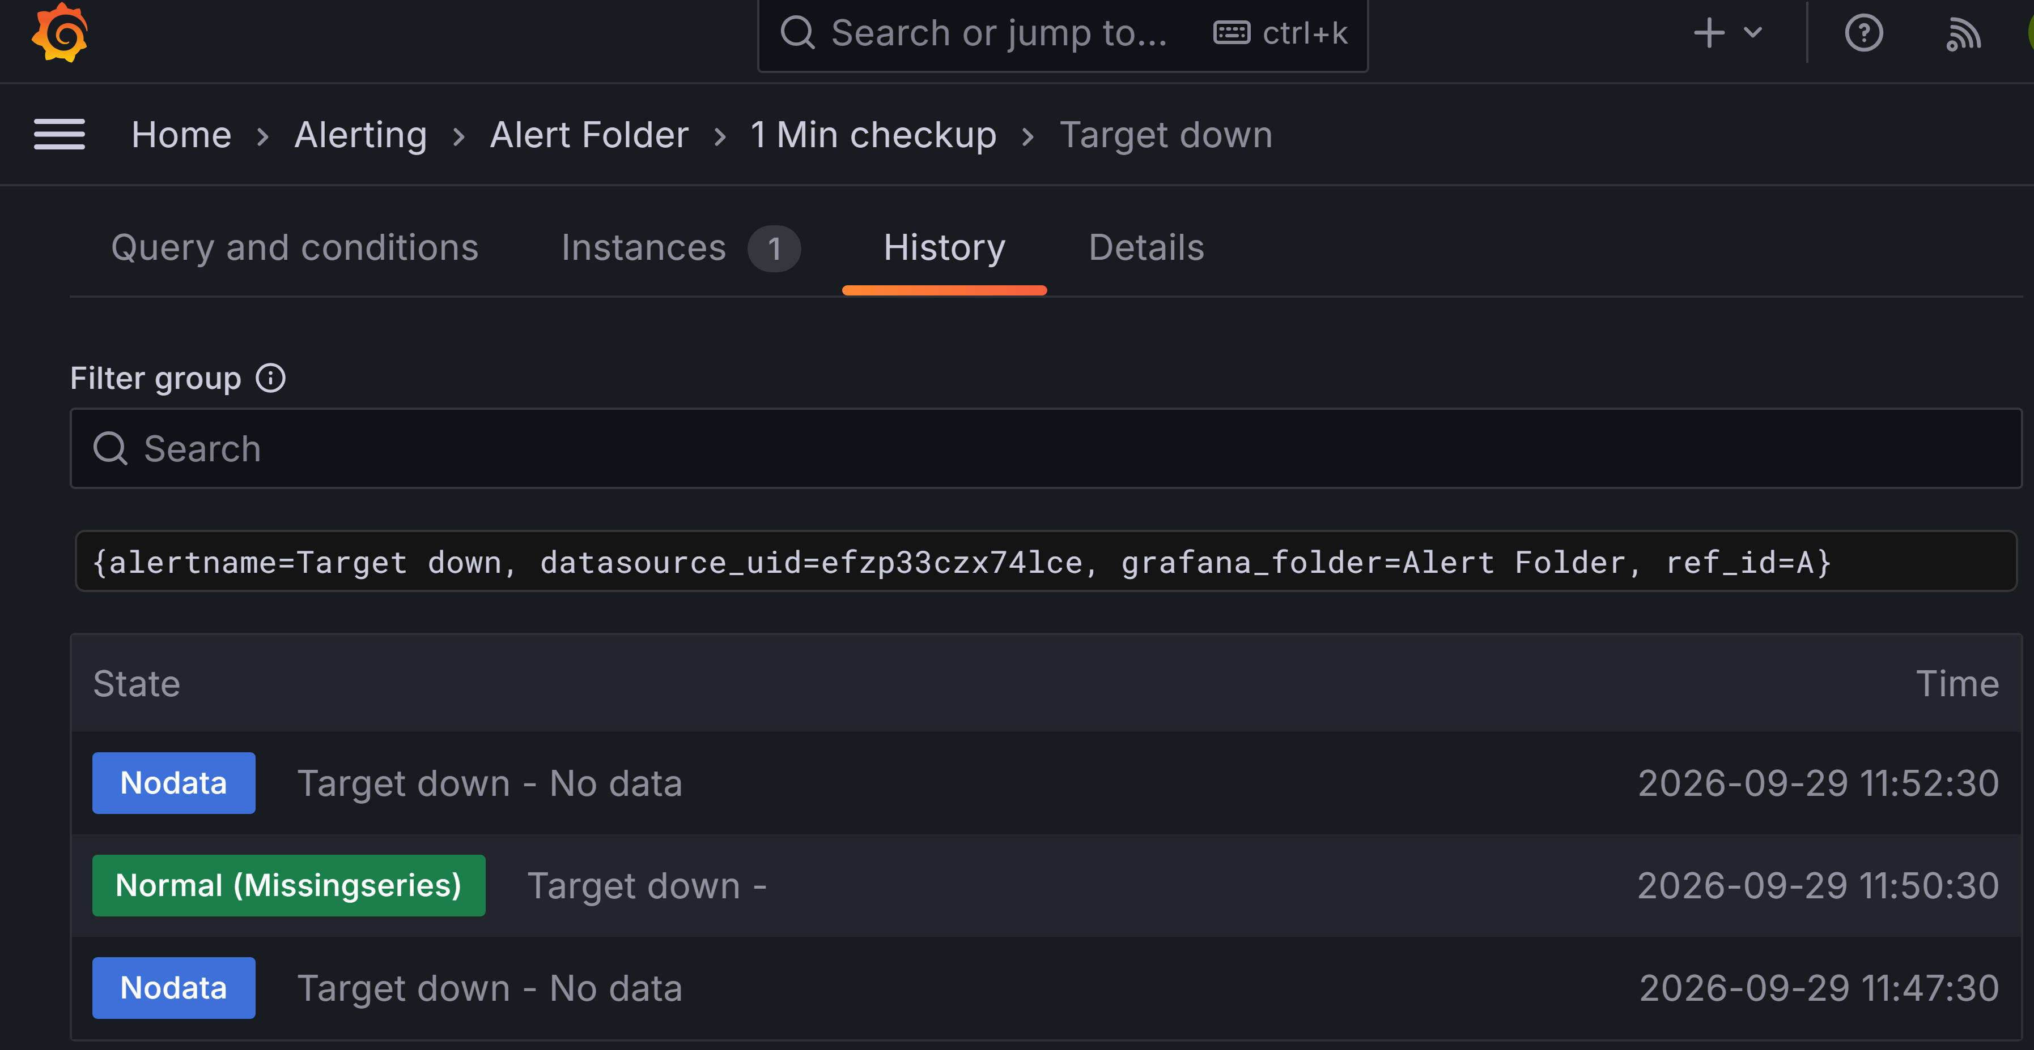
- Description: Screenshot showing both the Grafana Alerting UI history and the corresponding message delivered into the Discord channel.

T-10: Monitoring Metric Justification & Scaling Alignment
- Objective: Validate that chosen monitoring metrics directly support autoscaling policies and system design requirements.
- Execution Method: Evaluated baseline CPU usage against HTTP throughput during initial load testing rounds to assess signal suitability for autoscaling.
- Expected Result: Metric choice aligns with system performance bottlenecks.
- Actual Result: Testing revealed that the application workload is primarily I/O-bound (waiting on database connections and network sockets) rather than CPU-bound. Standard CPU metrics did not spike fast enough to trigger timely autoscaling. The scaling strategy was adjusted to track ALB requests-per-target instead (T-12).
- Verdict: PASS (Design-Level Validation)

5. Scaling, Resilience, and Self-Healing Results

T-11: Sustained Load Generation & Bottleneck Analysis
- Objective: Evaluate system behavior, throughput boundaries, and latency distribution under sustained concurrent user traffic.
- Execution Method: Launched a load test against the public ALB endpoint using the hey HTTP benchmarking tool: hey -z 5m -c 100 http://<ALB-DNS-NAME>/.
- Expected Result: System handles incoming traffic within known boundaries, showing clear latency queuing behavior under high concurrency.
- Actual Result: Generated ~36,000 total HTTP requests over 5 minutes with a $99.99\%$ success rate. The web tier achieved a throughput ceiling of ~120 req/sec. Latency metrics displayed clear queuing signatures: 50th percentile response time was 0.19s, while the 99th percentile rose to 6.58s under maximum queue depth.
- Verdict: PASS
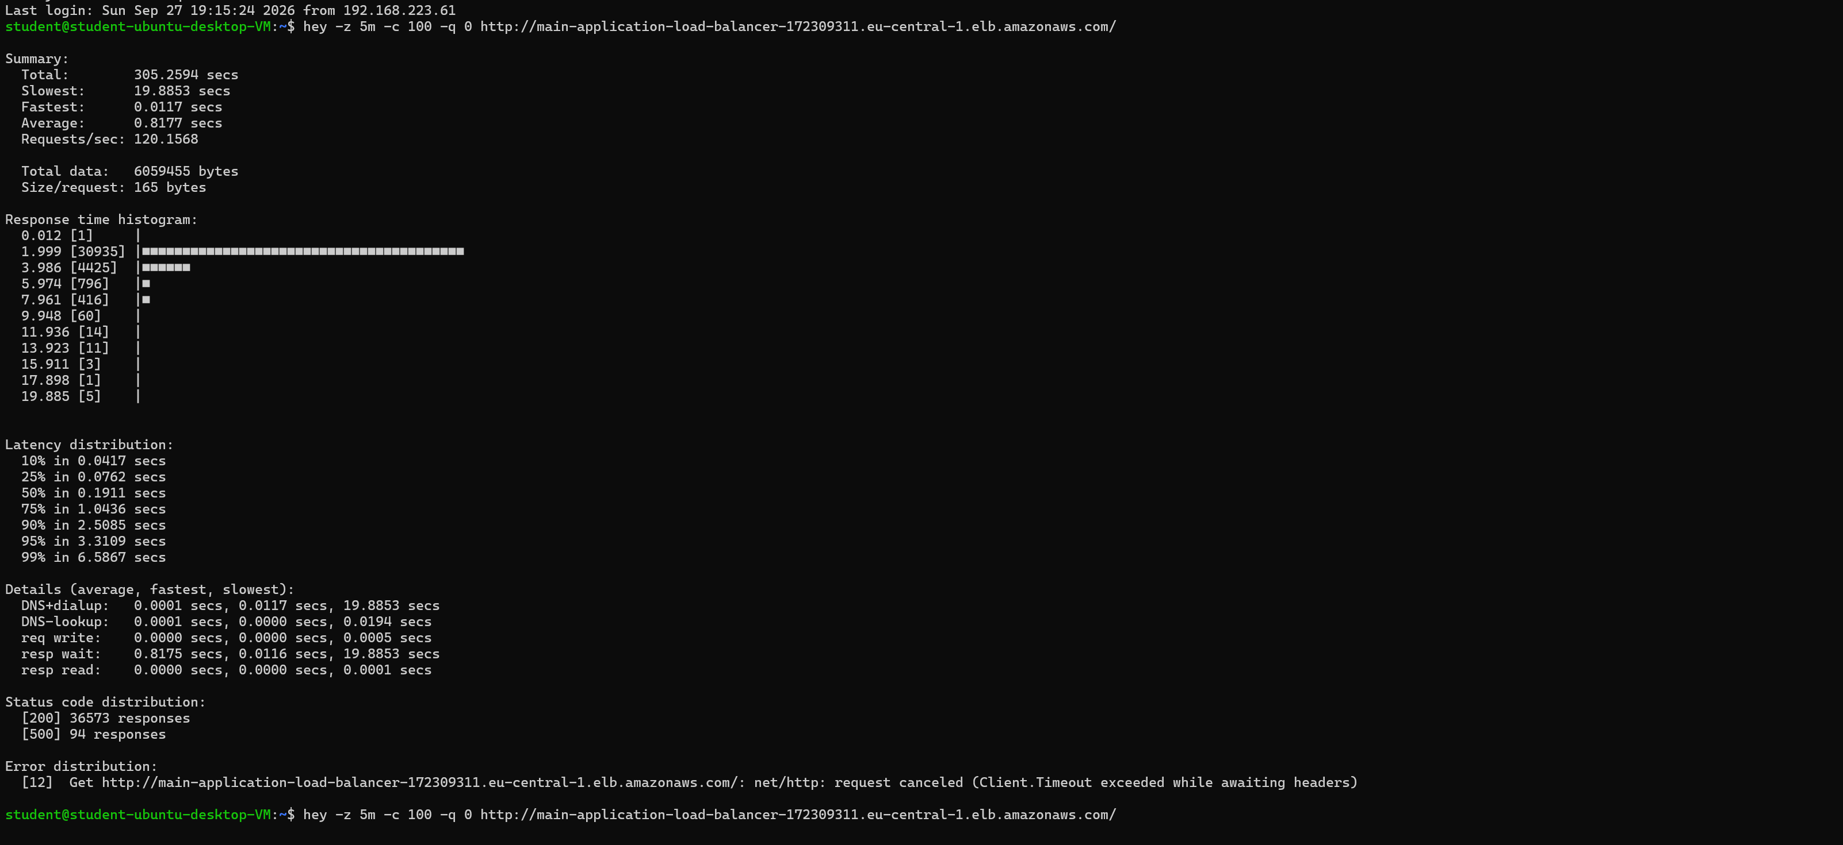
- Description: Terminal screenshot showing the raw summary output of the hey tool execution (requests/sec, total status codes, latency histogram).

T-12: Target-Tracking Auto Scaling Trigger
- Objective: Verify that the Auto Scaling Group automatically provisions additional EC2 web nodes when load crosses the configured requests-per-target threshold.
- Execution Method: Monitored AWS ASG activity and Grafana metric panels while executing the sustained hey load test (T-11).
- Expected Result: Target tracking policy detects the spike in ALBRequestCountPerTarget and scales out the fleet beyond its minimum capacity of 2 nodes.
- Actual Result: Scale-out event was triggered. The ASG expanded capacity from 2 to 3 instances (up to the max limit of 4). The new instance was automatically registered with the ALB target group and added to Prometheus scrapers.
- Verdict: PASS
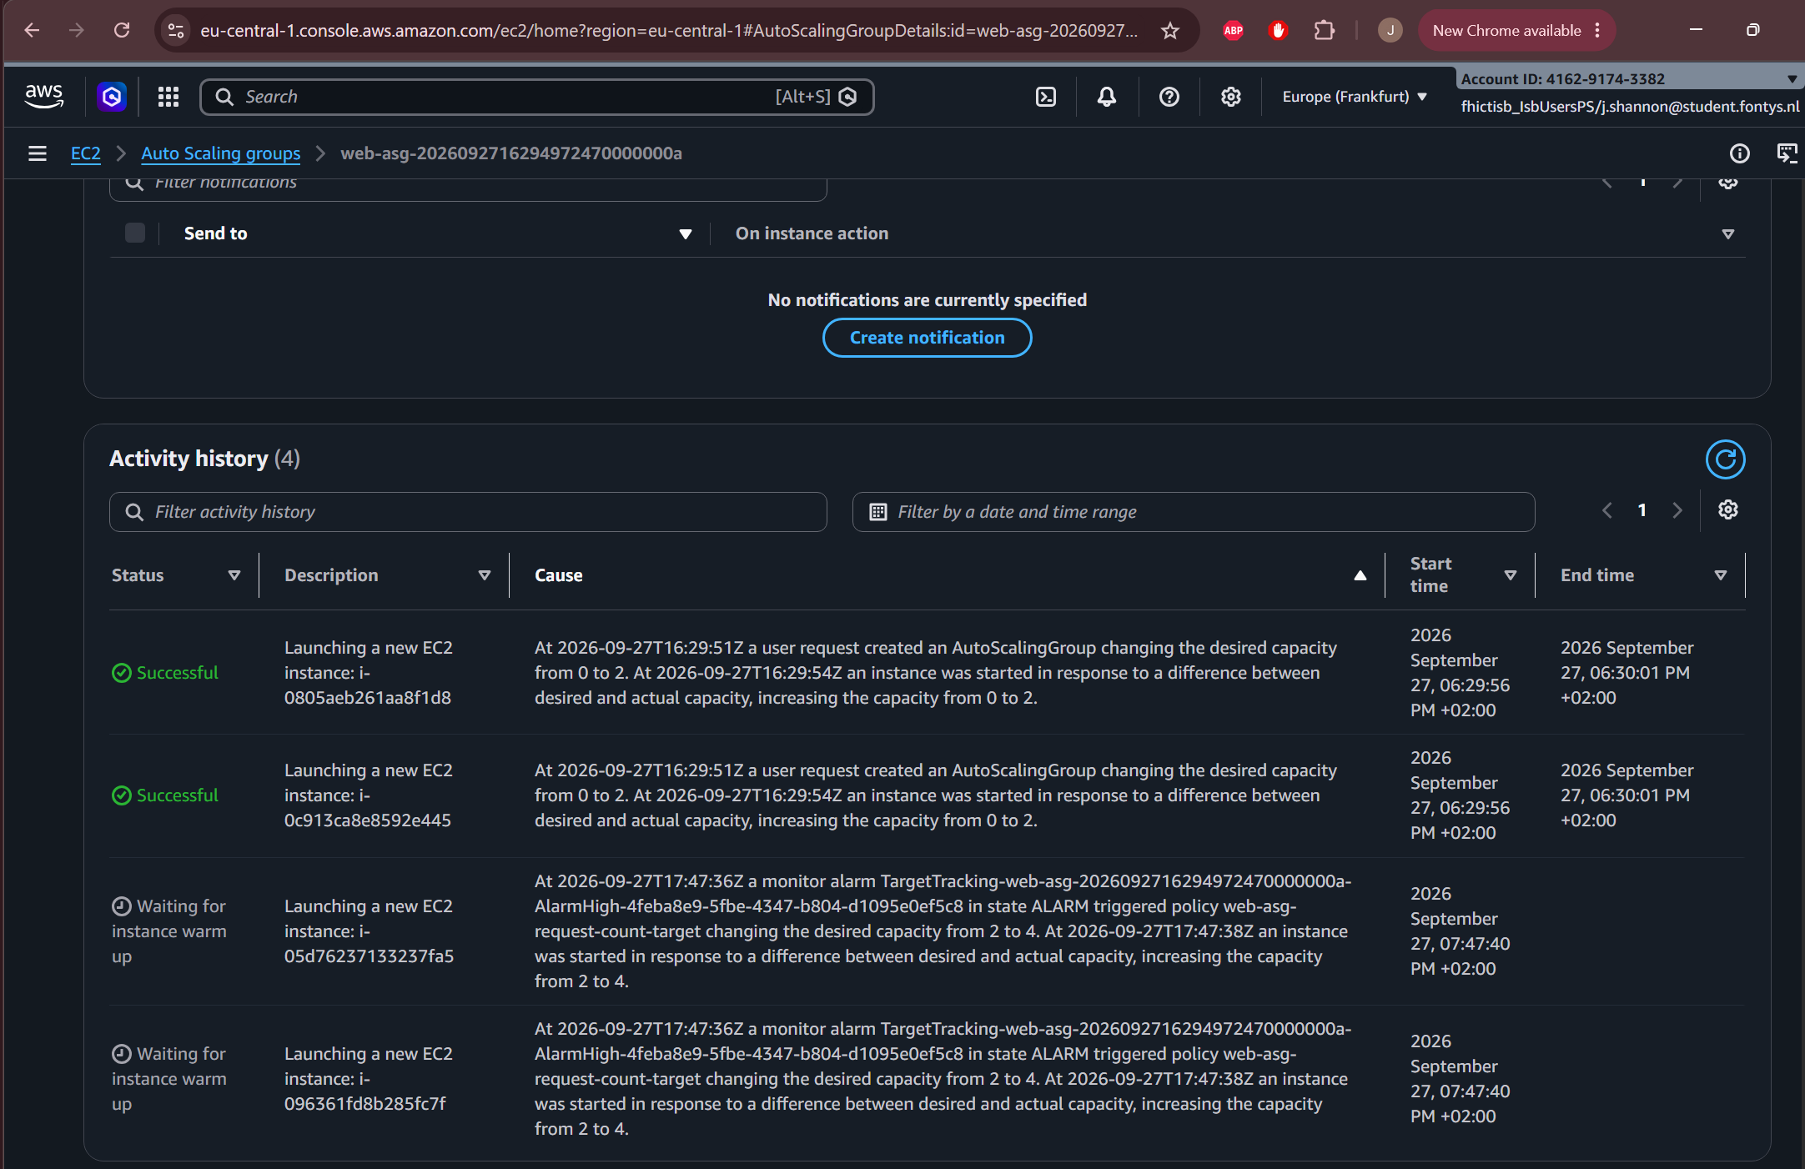
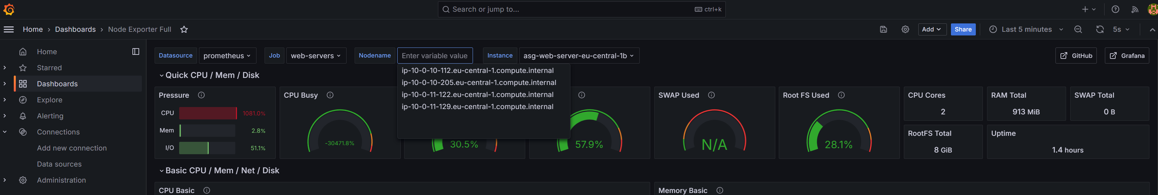
- Description: Dual screenshot showing (1) the AWS EC2 Auto Scaling Activity history logging the launch of a new instance, and (2) Grafana showing 3rd and 4th instance line appearing on the time-series graph.

T-13: Scale-In & Cost Optimization Behaviour
- Objective: Confirm that the cluster scales back down to its baseline minimum capacity once high load ceases, avoiding unnecessary operational costs.
- Execution Method: Observed cluster capacity in the AWS Console and Grafana for 30 minutes following the completion of the hey load test.
- Expected Result: ASG safely terminates excess instances and stabilizes at desired_capacity = 2.
- Actual Result: The fleet returned to 2 instances approximately 30 minutes post-test. This stabilization window is consistent with AWS default cooldown periods designed to prevent rapid scale-in/scale-out oscillations ("flapping").
- Verdict: PASS
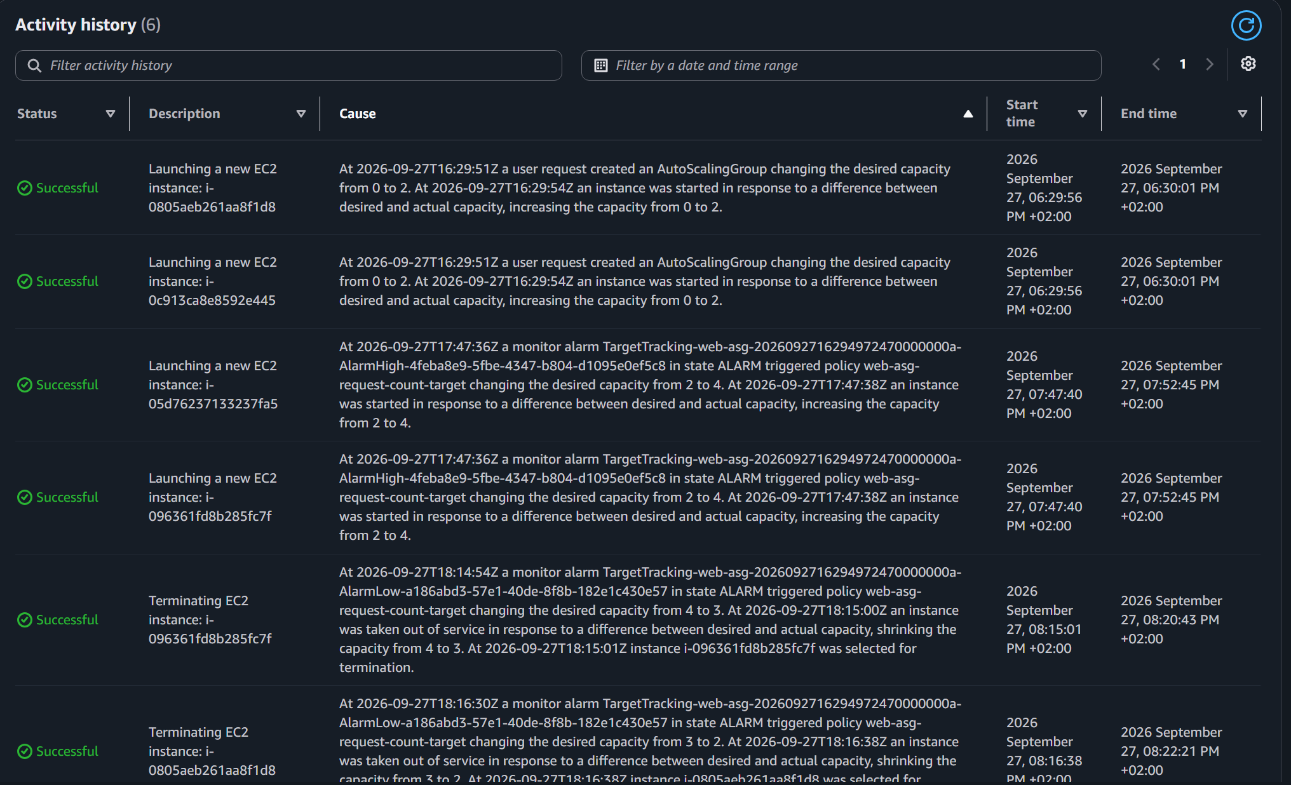
Description: Screenshot showing the newly created instances (bottom 2) already finished being terminated from the decrease of the workload with the timestamps on the right with how long it took.

T-14: EC2 Instance Self-Healing Verification
- Objective: Validate that the environment automatically recovers from hardware or OS-level instance crashes without operator intervention.
- Execution Method: Manually terminated one active web EC2 instance via the AWS EC2 Management Console while continuously polling the web endpoint.
- Expected Result: The ALB detaches the failing instance, and the ASG launches a replacement while maintaining public web accessibility.
- Actual Result: The ASG marked the terminated instance as unhealthy, removed it from the ALB target group, and launched a replacement node. The new node initialized, passed health checks, and joined the target group within ~4 minutes. User-facing requests served by the remaining node experienced zero HTTP 5xx errors.
- Verdict: PASS
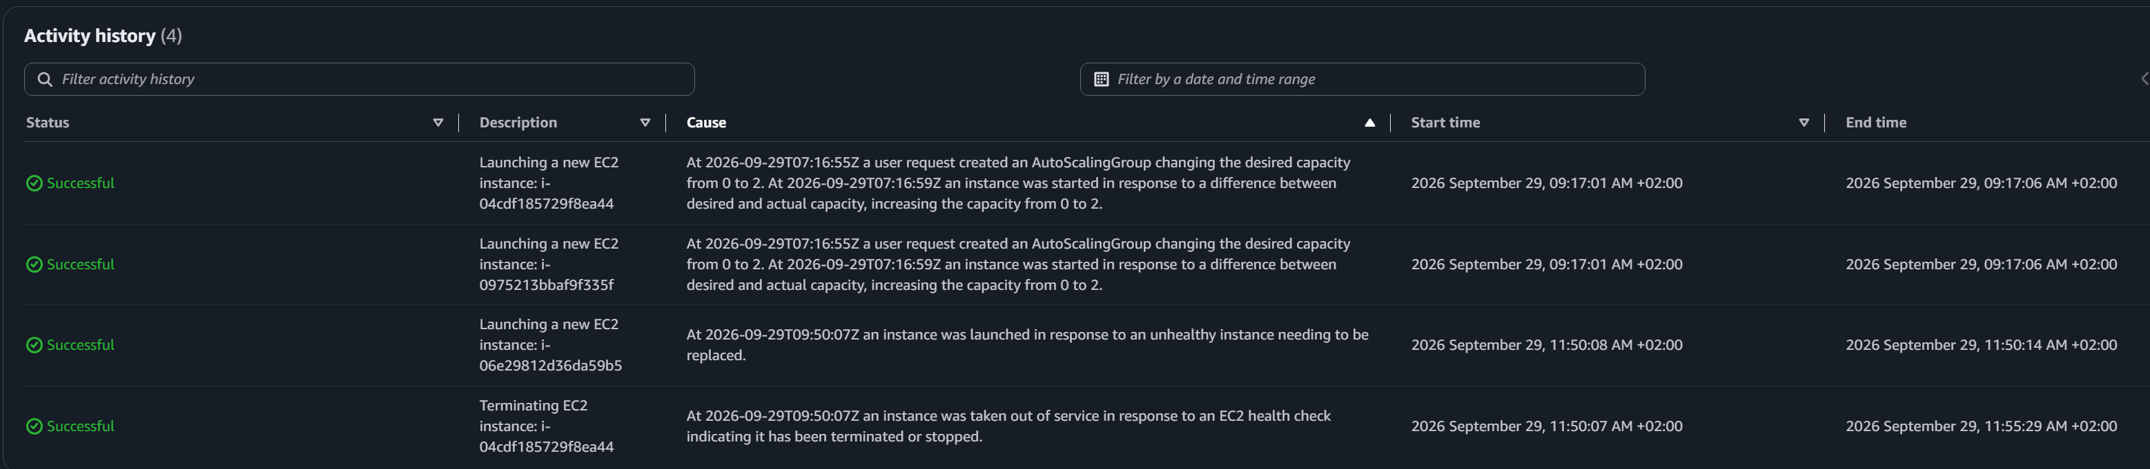
- Description: Screenshot of the AWS ASG Console of the Activity history showing one instance in "Terminated" state alongside a new instance in "Launching" state under the same Auto Scaling Group at the bottom 2 of the logs.

T-15: Zero-Downtime Rolling Deployment
- Objective: Verify that updates to the EC2 Launch Template (e.g., modified user data or updated application containers) deploy progressively across the fleet with zero service disruption.
- Execution Method: Triggered an instance refresh in the ASG following an update to the launch template, while issuing continuous HTTP requests against the ALB.
- Expected Result: Instances are replaced sequentially (create_before_destroy). The ALB routes traffic only to nodes that pass health checks.
- Actual Result: Both running instances were upgraded one-by-one. Continuous polling returned $100\%$ HTTP 200 responses throughout the rolling update.
- Verdict: PASS

6. Security & Compliance Test Results

T-16: Keyless Pipeline Authentication via OIDC
- Objective: Verify that the GitHub Actions CI/CD deployment pipeline authenticates to AWS without utilizing long-lived access keys or hardcoded repository secrets.
- Execution Method: Examined GitHub Secrets configuration and inspected the CI/CD job logs for the aws-actions/configure-aws-credentials step and aws sts get-caller-identity command.
- Expected Result: Authentication is achieved using short-lived IAM session tokens issued through OIDC federation.
- Actual Result: Zero static AWS keys are stored in GitHub. Execution logs confirm authentication as the assumed role app-github-deployer. AWS CloudTrail logs recorded the web-identity exchange per run.
- Verdict: PASS
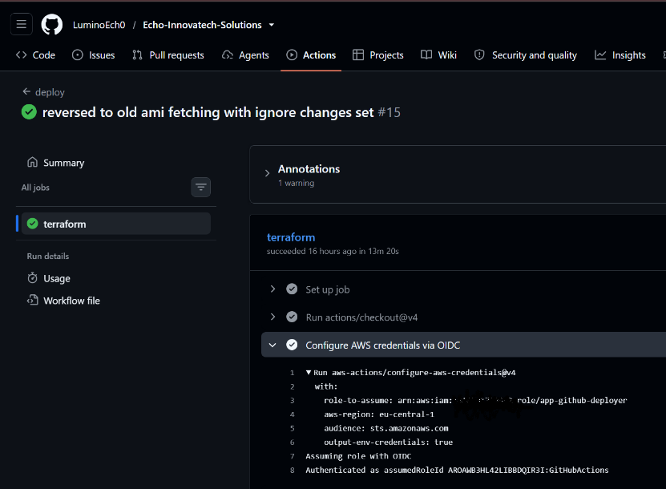
- Description: Screenshot of the GitHub Actions build log showing the sts get-caller-identity output displaying the assumed IAM role ARN.

T-17: Enforcement of Least-Privilege IAM Boundaries
- Objective: Ensure the pipeline deployment identity operates under restricted IAM policies and cannot perform unauthorized administrative actions.
- Execution Method: Simulated an unauthorized deployment step within the GitHub Actions workflow that attempted to provision an IAM role outside the permitted app-* resource path.
- Expected Result: AWS IAM evaluates the permissions boundary and denies the action with an explicit AccessDenied exception.
- Actual Result: The deployment job failed as expected with an AccessDenied error on iam:CreateRole, confirming that permission boundaries effectively block privilege escalation attempts outside designated resource namespaces.
- Verdict: PASS

T-18: Multi-Tier Network Segmentation Verification
- Objective: Confirm that security group ingress/egress rules strictly enforce network isolation between subnets and block unauthorized cross-tier communication.
- Execution Method: Issued nc (netcat) probes from the management/VPN host toward non-permitted ports (e.g., trying to hit Node Exporter port 9100 on web nodes directly from management, or ICMP pings across isolated subnets).
- Expected Result: Probes to non-permitted ports time out, while authorized ports connect successfully.
- Actual Result: Connection attempts to unauthorized ports (such as port 9100 from the VPN host) timed out. Port 9100 accepted traffic only when queried from the dedicated monitoring instance IP. Egress and ingress boundaries functioned as specified.
- Verdict: PASS
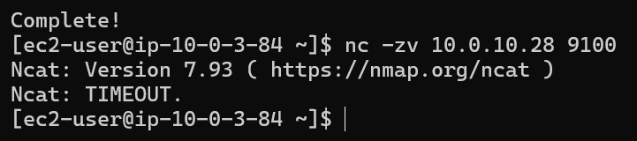

7. Failure Scenarios and Recovery Operational Analysis
The following section documents real-world failure conditions observed during infrastructure testing, detailing the system's automated recovery responses and operational procedures:

Web Instance Hardware / OS Crash
- Observed System Behavior: The AWS Auto Scaling Group health check detected instance unresponsiveness. The ALB immediately deregistered the target to prevent routing traffic to a dead node.
- Recovery Mechanism: Automated. The ASG terminated the degraded node and spawned a fresh instance from the latest Launch Template version in ~4 minutes.
- Assessment: Fully satisfies target availability requirements for the compute tier.

Application Container Crash
- Observed System Behavior: If the internal Flask or Gunicorn process fails inside the Docker container, Nginx returns localized connection errors.
- Recovery Mechanism: Automated. The Docker daemon --restart always restart policy automatically restarts crashed containers locally. If the container remains unhealthy, the ALB target health check fails, triggering instance replacement.
- Assessment: Reliable multi-layered self-healing; requires zero manual intervention.

Sudden Traffic Saturation Bottleneck
- Observed System Behavior: Sustained concurrent requests led to elevated queue depths and increased latency percentiles prior to scale-out completion.
- Recovery Mechanism: Automated scaling via Target Tracking Policy (T-12).
- Assessment: Testing revealed that backend database connections were the primary performance bottleneck rather than CPU. Updating the scaling trigger metric to ALB requests-per-target drastically improved autoscaling responsiveness under load spikes.

Pipeline Infrastructure Teardown Failure (Dependency Violation)
- Observed System Behaviour: Running terraform destroy occasionally failed when attempting to tear down the VPC, returning a Dependency Violation error caused by lingering ENIs associated with NAT Gateways or Elastic IPs.
- Recovery Mechanism: Manual Operational Procedure. Disassociate dependent Elastic IPs and clear remaining NAT Gateway endpoints prior to re-issuing the destruction workflow.
- Assessment: Documented as a known operational nuance in the runbook. Acceptable for Proof of Concept (PoC) scope.

Pipeline State Discrepancies
- Observed System Behaviour: Ephemeral build runner environments risk losing Terraform local state files between execution runs if runner storage is recycled.
- Recovery Mechanism: Mitigated by binding pipeline state storage to a persistent directory on the dedicated vSphere runner VM.
- Assessment: Production deployment recommendations include migrating state management to a remote S3 backend with DynamoDB state locking.

8. Conclusion
All planned functional, security, and resilience tests were executed successfully against the deployed AWS cloud environment.
The two most significant engineering outcomes derived from this test plan were:
- Empirical Performance Tuning: Load testing (T-11) proved that the application architecture is I/O-bound rather than CPU-bound. This empirical finding led directly to replacing the original CPU-based autoscaling signal with an ALB Request Count Per Target tracking policy—a design improvement grounded in actual measurement rather than initial assumptions.
- Infrastructure Reproducibility: Conducting full automated teardown and rebuild cycles confirmed that the entire 2-tier environment, including monitoring and security boundaries, can be completely recreated via the CI/CD pipeline without manual cloud console steps.

